Lab 2: Vivado Intro / Structural Decoder

Author: Seth Ricks
Date: 9/22/2025
Class: ECEN 340

Purpose:
- To review the Basys 3 board
- To review Vivado usage
- To implement a simple structural Verilog design

Procedure:
Part 1 – (First Lab Day) Download the Basys3 Vivado Decoder Tutorial. Follow the instructions in the tutorial until you have a functioning decoder.

Part 2 – Create a new decoder project with a different name and implement the same design using structural Verilog (gate-level) design techniques.
- Open the schematic view in Vivado, and study/understand the implementation
- Use “or, and” and other structural Verilog statements to implement the Decoder

Results/Report:
Part 1:

In this section of the lab, we were given some code to write on the Basys3 board. This code can be seen below in Figure 1.

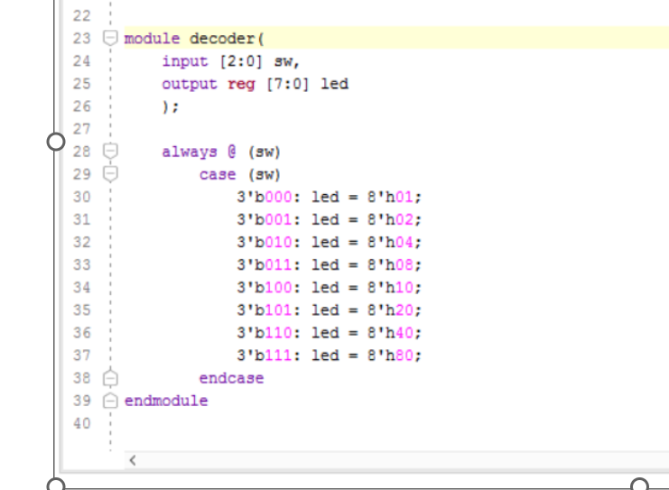
Figure 1

When we synthesized this code, the Basys3 board created the schematic below in Figure 2.

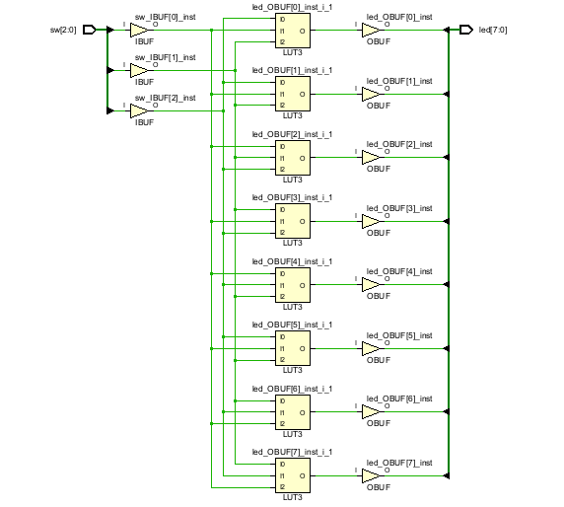
Figure 2

This part of the lab allowed us to re-familiarize ourselves with how to set up Vivado, and how to work with Basys3 board. With this code we wrote to the board, we were able to control 8 on-board LEDs with 3 switches. This corresponded to a binary to decimal converter. For example, if the switch code was ‘0,1,1’, LED #3 turned on.

Part 2:

This part of the lab tasked us to re-write the aforementioned code in a more primitive manner. This meant that we needed to write the actual gates for each output logic. To do this, I created a logic table for the output we want. This can be seen in Table 1 below.

X₁ | X₂ | X₃ |  | L₇ | L₆ | L₅ | L₄ | L₃ | L₂ | L₁ | L₀
0 | 0 | 0 |  | 0 | 0 | 0 | 0 | 0 | 0 | 0 | 1
0 | 0 | 1 |  | 0 | 0 | 0 | 0 | 0 | 0 | 1 | 0
0 | 1 | 0 |  | 0 | 0 | 0 | 0 | 0 | 1 | 0 | 0
0 | 1 | 1 |  | 0 | 0 | 0 | 0 | 1 | 0 | 0 | 0
1 | 0 | 0 |  | 0 | 0 | 0 | 1 | 0 | 0 | 0 | 0
1 | 0 | 1 |  | 0 | 0 | 1 | 0 | 0 | 0 | 0 | 0
1 | 1 | 0 |  | 0 | 1 | 0 | 0 | 0 | 0 | 0 | 0
1 | 1 | 1 |  | 1 | 0 | 0 | 0 | 0 | 0 | 0 | 0
Table 1

From this table, I was able to derive 8 logic statements:
$L_{0}=(X_{1}X_{2}X_{3})'$
$L_{1}=X_{1}'X_{2}'X_{3}$
$L_{2}=X_{1}'X_{2}X_{3}'$
$L_{3}=X_{1}'X_{2}X_{3}$
$L_{4}=X_{1}X_{2}{'X}_{3}'$
$L_{5}=X_{1}{'X}_{2}X_{3}'$
$L_{6}=X_{1}{'X}_{2}'X_{3}$
$L_{7}=X_{1}'X_{2}'X_{3}'$

I then implemented these logic statements into Verilog code that I uploaded into our development board. The code required 8 AND gate statements, which can be seen in our code in Figure 3 below.

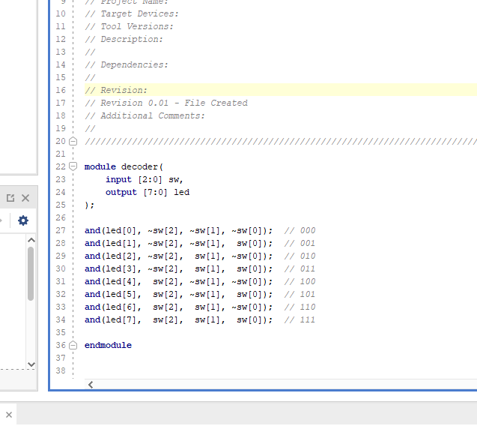
Figure 3

This code worked as intended. The three switches corresponded to 8 LEDs on the board, essentially creating the binary-to-decimal converter for 3 bits. Vivado also created another schematic with this code, which can be seen in Figure 4 below.

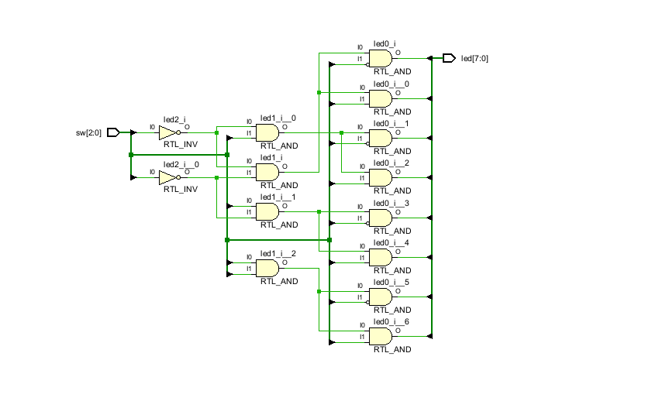
Figure 4
Conclusion:

This lab was a great introduction/review for Vivado. I vaguely remembered how to set up a project, but this solidified it for me. It was also helpful to remember how to use the Basys3 board. Despite this, I am still struggling with some aspects of the Verilog language. For example, to implement my version of this logic I had to remove the ‘reg’ statement for the LED output. As far as I understand, ‘reg’ is for blocks like always, and ‘wire’ is for things that need to be continuously driven. I hope to understand this more in future lab and class experiences. I also hope to understand Verilog syntax better in general over the course of this class.

